Assignment
Merge to csv files in scala and write some use cases

Merge Two CSV Files
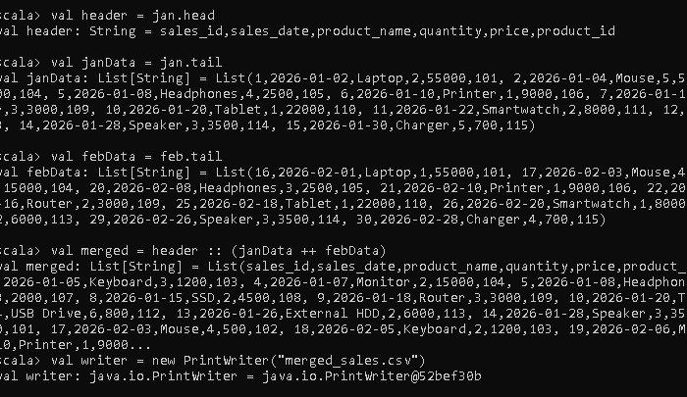

Total Revenue Calculation
This use case calculates the overall revenue generated from all sales records.
Revenue is computed by multiplying quantity and price for each transaction.
Code
val totalRevenue = columns
.map(x => x(3).toInt * x(4).toInt)
.sum

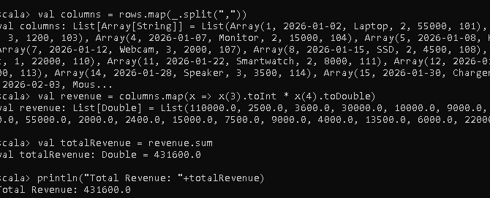

Total Quantity Sold per Product
This use case calculates the total number of units sold for each product.
The records are grouped by product name and their quantities are summed.
Code
val quantityByProduct = columns
.map(x => (x(2), x(3).toInt))
.groupBy(_._1)
.mapValues(v => v.map(_._2).sum)
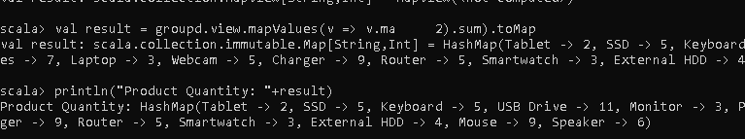

Revenue Generated per Product
This use case calculates how much revenue each product generated.
Revenue for each row is computed and then aggregated by product.
Code
val revenueByProduct = columns
.map(x => (x(2), x(3).toInt * x(4).toInt))
.groupBy(_._1)
.mapValues(v => v.map(_._2).sum)

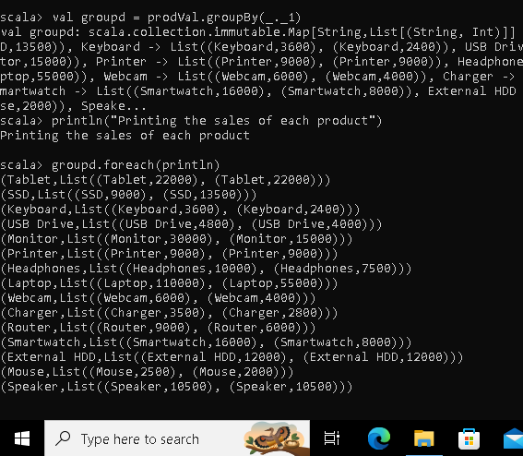

Highest Revenue Sale
This use case identifies the transaction that generated the highest revenue.
It compares revenue values of all sales and returns the maximum one.
Code
val highestSale = columns
.map(x => (x(0), x(2), x(3).toInt * x(4).toInt))
.maxBy(_._3)

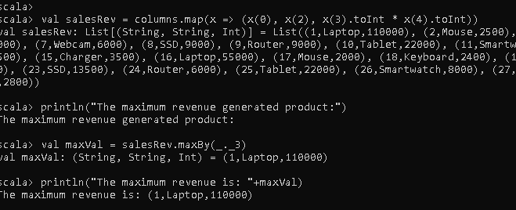

Top Selling Product
This use case finds the product with the highest number of units sold.
It aggregates quantities by product and selects the product with maximum sales.
Code
val topProduct = columns
.map(x => (x(2), x(3).toInt))
.groupBy(_._1)
.mapValues(v => v.map(_._2).sum)
.maxBy(_._2)

